Link: <https://crackmes.one/crackme/5c90a72d33c5d4776a837f07>

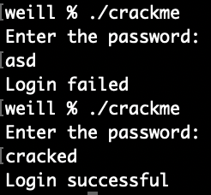

Upon inspection of the disassembled code, it is clear that it checks for a

string of length 7. After a lot of researching on what different commands

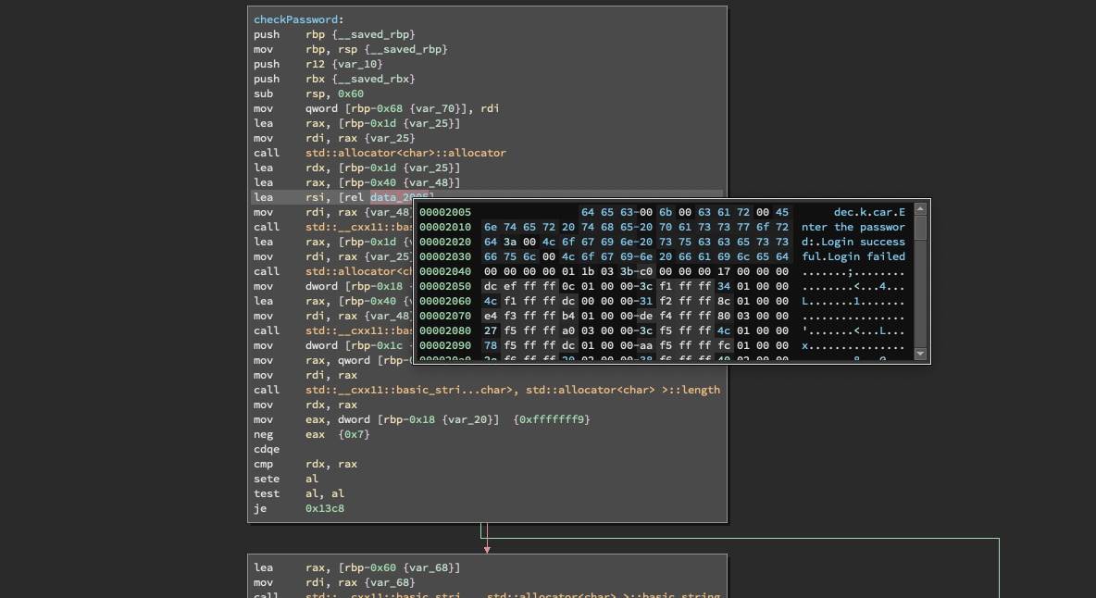and register mean I found two variables. They contained the letters dec, k, car. I quickly realised that’s an anagram for cracked. 'cracked' is also a 7 letter word. I entered the password and I was correct.